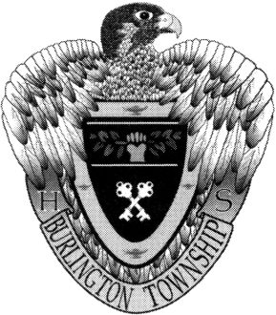

**BURLINGTON TOWNSHIP HIGH SCHOOL**

610 FOUNTAIN AVENUE, BURLINGTON TOWNSHIP, NJ 08016-3314

MAIN OFFICE: 609-387-1713

HOPKINS OFFICE: 609- 387- 3774

PHIL BROWNRIDGE CHRISTOPHER ILCONICH NAOMI A. THREADGILL NEAL CANAVAN PETER E. TEIFER JAMES S. MILLS

*Principal Vice Principal Vice Principal Vice Principal Co-Curricular Supervisor District Director of Guidance*

August 19, 2016

Dear Parent or Guardian,

This letter is being sent to you because your son or daughter signed up to take one or more of the Rowan College at Burlington County(RCBC) courses that will be taught at BTHS during the 2016-2017 school year. Introduction to Criminal Justice will be taught during the 1st semester and American Sign Language will be taught in the 2nd semester. College professors assigned by RCBC will teach these courses. Each course will be taught on Monday, Wednesday, and Friday during Block 1-2 (7:20-8:36).Students will have the option of coming in to school at the end of Block 1-2 on the days the class is not taught (Tuesday and Thursday) if they have their own transportation, or they may come to school at the regular time and we will assign them a room where they can access a computer to do work for their college course. The tuition rate for each course as set by RCBC will be $406.50. Students are also responsible for the cost of the book. The RCBC course registration form is enclosed in this mailing **for those students who have signed up for the 1st semester Criminal Justice course.** A separate mailing with specific details about the second semester courses will be mailed later in the fall.

Students taking the Intro to Criminal Justice course should complete the enclosed RCBC application. Please fill out all areas of the application that are underlined, **including your student’s Social Security Number** which RCBC must have in order to process the application. Also, please make sure both you and you student’s signatures are on the form. **The “College Course in Which You Plan to Enroll” section has already been filled out.**

The book for the Criminal Justice course is ***Experience Criminal Justice*** by Nicole Hendrix, 1st or 2nd edition, published by McGraw-Hill. The book can be purchased at the college bookstore on the Mt. Laurel campus. You can reach the RCBC Bookstore on the Mt. Laurel campus at (856) 222-9311 x2640. Depending on availability, the book may be available to rent or you may be able to purchase a used book. The book may also be available from an online provider such as Amazon. The completed RCBC application along with a check made out to RCBC for $406.50 is due in the Counseling Office by **Monday, September 12th.** The 1st session for the Intro to Criminal Justice class will be on Wednesday, September 7th. However, all students should report to school at 7:20 am on Tuesday, September 6th.

If for some reason your son or daughter has decided not to take the RCBC course, they should contact the Counseling Office at 387-1713 extension 5 before the opening of school so that they can be scheduled into another class. If you have any questions please feel free to contact me at the number listed above or at [jmills@burltwpsch.org](mailto:jmills@burltwpsch.org). . Enjoy the remainder of your summer.

Sincerely yours,

James S. Mills

District Director of

Pupil Personnel Services